CRICKET MANAGEMENT SYSTEM -

SRS DOCUMENTATION

**A. MOKSHITH (2101049)**

**D.HARSHA VARDHAN (2101070)**

**J. ABHINAY (2101093)**

# 1)Introduction

Cricket management system is basically a web-based application designed to manage and provide cricket player stats in various formats. The main goal of application is to provide users with a comprehensive platform to access detailed information about cricketers and their performance statistics through seamless API integration.

# 2)Purpose

The purpose of the Cricket Management System is to offer a user-friendly interface that allows users to search for cricketers by name and retrieve detailed statistics for individual players. The system aims to present the data in various formats, making it easy for users to analyse and compare player’s performances.

# 3)Scope

1. **Player Database**
2. **Search functionality**
3. **Player Statistics**
4. **User Authentication**
5. **Match scheduling**

4)FUNCTIONAL REQUIREMENTS:

1. **Player and Team Management:**

The system provides the ODI, T20I and Test statistics of each player, including personal details, style, role and adds the new players to their nation if they were debuted. It should also provide identifier to API integration.

1. **Player and Team rankings:**

The system automatically provides the player and team rankings in all three formats of the game and upgrades it from time to time.

1. **Login and registration:**

The system should ask for registration if the user is not yet registered and if registered system shall ask for login credentials for authentication.

1. **Team schedules and archives:**

The system provides the details of upcoming matches which includes date, time, venue and two participated teams. For completed matches, it additionally provides the result of the match along with the above listed details.

1. **API Integration:**

The system shall integrate with external APIs provided by the cricket boards or cricket data providers to achieve real time stats of the team and player. API calls shall made in safe, secure and smooth manner.

1. **Search Functionality:**

The user is allowed to enter any player or team name in the navigation bar. In case if the entered name is of player, then the system should show details of player or if the entered name is of team, then the system should show schedule of the team.

5) NON-FUNCTIONAL REQUIREMENTS:

1. **Performance:**

Efficient response time and throughput to handle concurrent users and satisfying them is of utmost priority of the system.

1. **Reliability:**

Availability of the data all the time and regular backups for prevention of the data loss should be ensured by the system.

1. **Usability:**

The user interface should be intuitive and responsive for better usage. System should support multiple browsers so that user can use it on his comfortable browser.

# 6)System requirements

( performance & capacity)

**6.1.1) Server Hardware**

* The server hosting the application should have a minimum of 4 GB RAM and a quad-core processor.
* Disk space requirements will be primarily determined by the application code, media storage, and any local caching needs.

**6.1.2) Database**

* Utilize a local database for caching purposes if needed, but its size will be minimal compared to a comprehensive player database.

**6.1.3) User Load**

* The system should be capable of handling concurrent user loads. Load testing should be conducted to identify the maximum number of concurrent users the system can support while maintaining acceptable response times.

**6.1.4) Optimization of API**

* Optimize external API calls for efficiency, and consider implementing local caching mechanisms to reduce the load on the external API.

6.1.5) Life cycle

Model-Iterative waterfall model

# Constraints

* The application shall be developed using Python (Django), JavaScript

(Node.js with Express.js) and react.js

* The system shall be compatible with major web browsers (Google Chrome, Mozilla Firefox).

# Updates Section

• This section will document any updates or changes made to the SRS document, including the date, description of changes, and the names of individuals involved.

9)Future enhancements

1)Live score Integration

# 10)Decision Tree

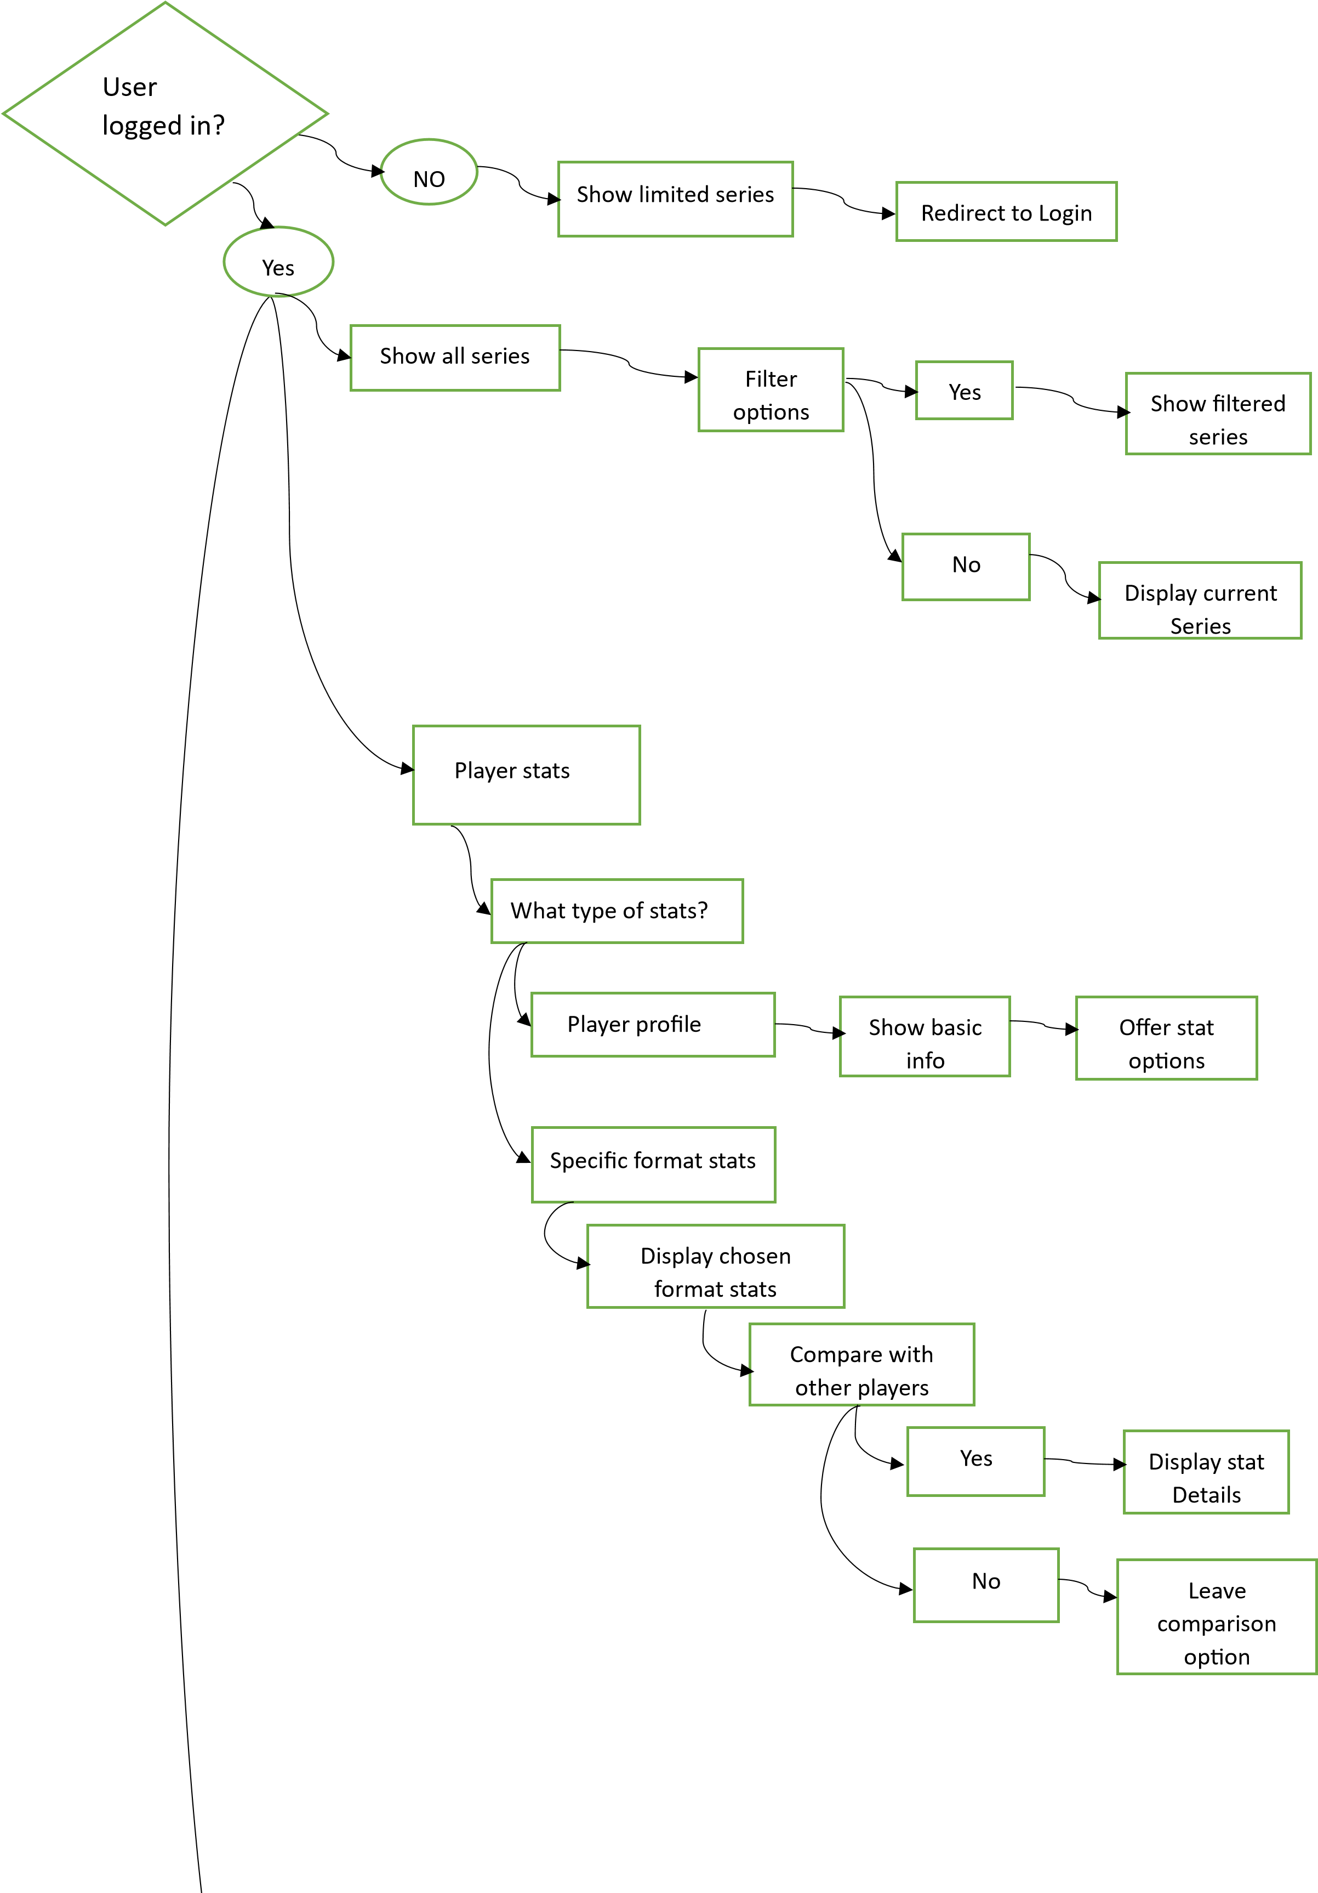

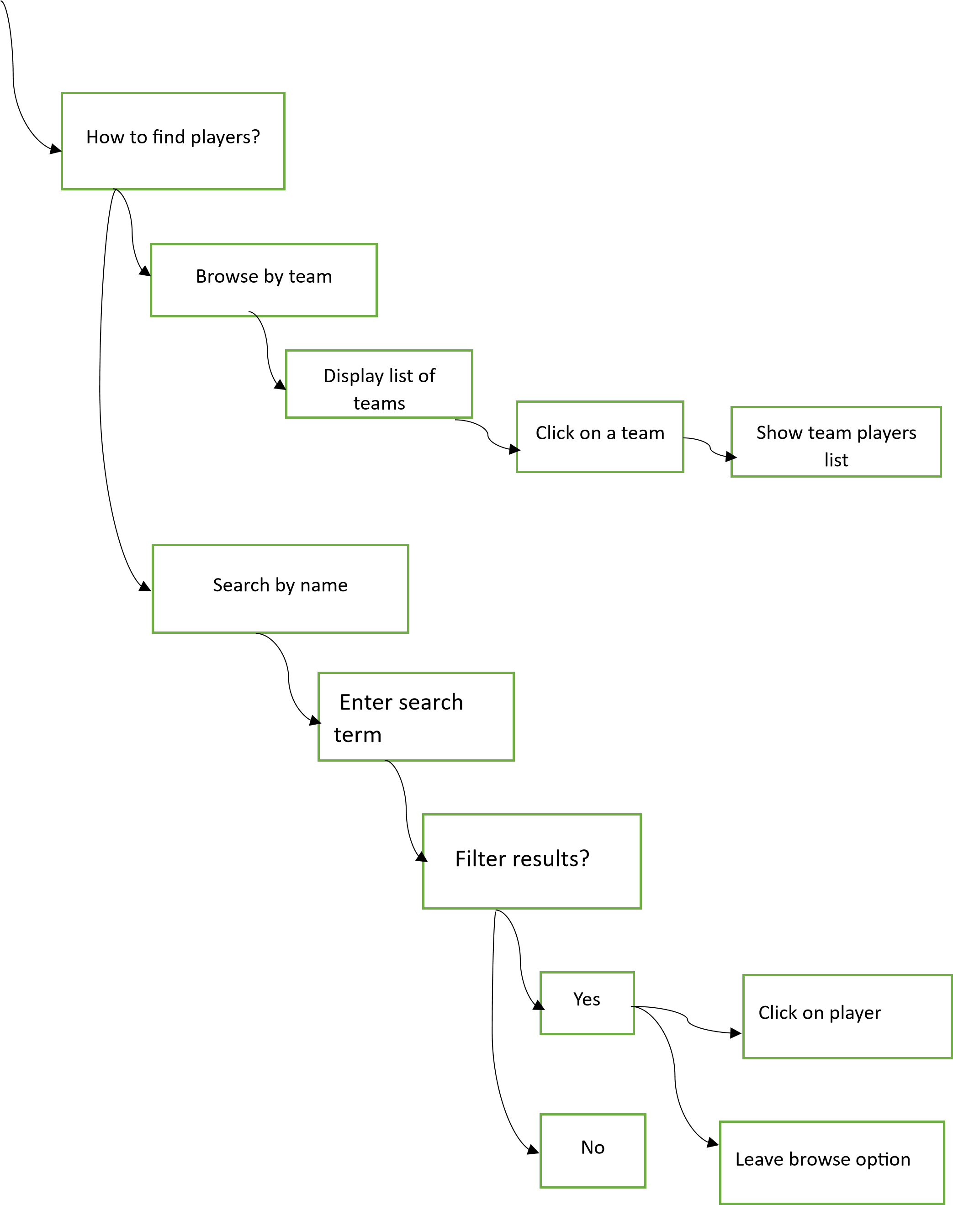

**11)DECISION TABLES**

**11.1) Decision Table:**

|  |  |  |  |
| --- | --- | --- | --- |
| **Condition** |  |  |  |
| User logged in | T | T | F |
| Selects filter | T | F | -- |
| **Action** |  |  |  |
| Display current series | -- | T | -- |
| Show limited number of upcoming series | -- | -- | T |
| Show filtered series | T | -- | -- |
| Redirect to login page | -- | -- | T |

**11.2) Decision Table:**

|  |  |  |  |
| --- | --- | --- | --- |
| **Condition** |  |  |  |
| User selects “Player Profile” | T | -- | -- |
| User selects “Specific format stats” | -- | T | T |
| User compares players | -- | T | F |
| Display chosen format stats | -- | T | T |
| **Action** |  |  |  |
| Show basic info & offer stat options | T | -- | -- |
| Display stat details | -- | T | -- |
| Leave comparison option | -- | -- | T |

**11.3) Decision Table:**

|  |  |  |  |
| --- | --- | --- | --- |
| **Condition** |  |  |  |
| User enters “search” term | T | T | -- |
| User selects team | -- | -- | T |
| Filter results | T | F | -- |
| **Action** |  |  |  |
| User clicks on a player | T | -- | -- |
| Show team players list | -- | -- | T |
| Leave Browse option | -- | T | -- |

# **12)Data Flow Diagram**

**12.1) DFD Level 0**

RETRIEVE STATISTICS

CRICKET

VIEW ADD

# User

MANAGEMENT Admin

LOGIN SYSTEM UPDATE REGISTER

0

**12.2) DFD Level 1**

PLAYER

VIEW

PLAYER INFO

PLAYER

TEAM

VIEW TEAM

RECORD

TEAM

INFO

RECORD

VIEW STATS

STATS

PLAYER STATISTICS

ACHIEVEMENTS

RETRIEVE STATS

TEAM ACHIEVEMENTS

RETRIEVE

PLAYER PERSONAL

ACHIEVE

MENT

DETAILS

PLAYER RANKS

RETRIEVE

RANK

ADMIN

EDIT

0.1

VIEW ANY

RECORD

0.2

R

ETRIEV

E

ANY RECORD

0.3

USER

RECORD

**2**

**DFD Level**

**12.3)**

DISPLAY RECORD

PLAYER RECORD

PLAYER INFO

RECORD

TEAM

RECORD

NAMES OF

TEAM INFO

BATSMEN

NAMES OF

BOWLERS

PLAYER ID

STATS

PLAYER NAME

PLAYER STATISTICS

TEAM ID

ACHIEVEMENTS

TEAM ID

TEAM

ACHIEVEMENTS

PLAYER

PLAY

ERNAME

PLAYER ID

PERSONAL

PLAYER ID

ADMIN

ADD

1.1

UPDATE

1.2

CALCULATE

1.3

VIEW RECORD

2

FETCH

BAT

_

NAME

3.1

FETCH

BOWL_NAME

3.2

HIGHEST

CENTURIES

3.3

NO.1 TEAM

3.4

BEST PLAYER

3.5

USER

PLAYER RANKS

DETAILS

## 13)Structured Chart

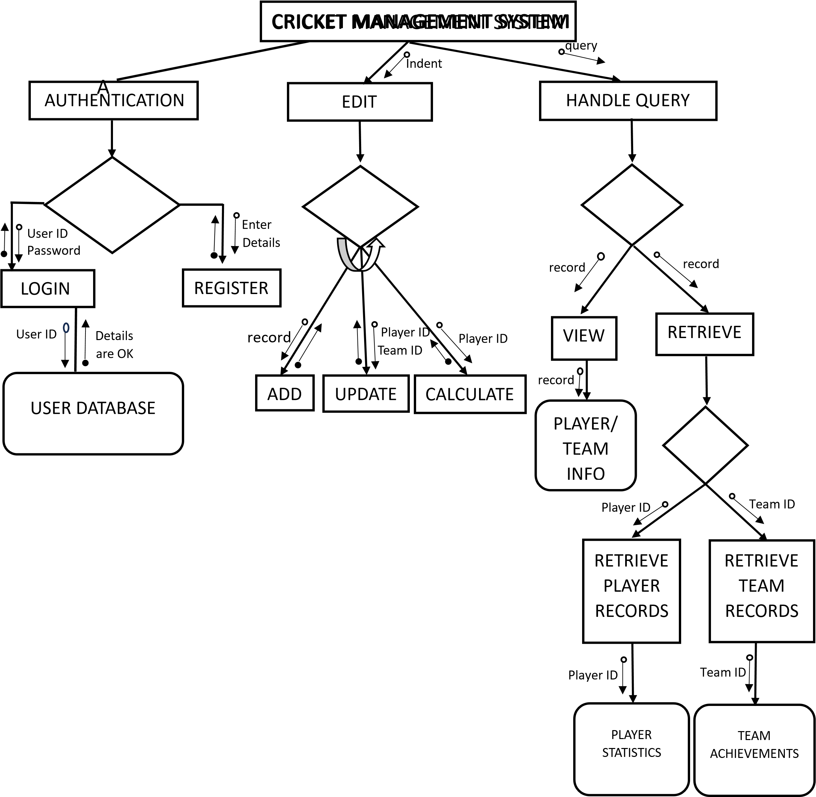

Password

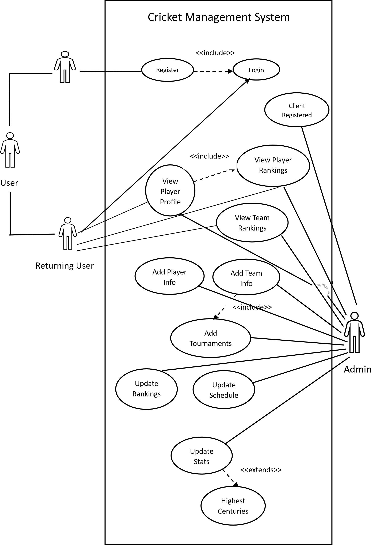 New User

**15)Use Case UML Sequence Diagram**

(i)Login Sequence Diagram

Verification

User Database

Login Page

User

Login to Page

New User

Jump to register page Check login details

Returning User Verify login details Verify

Return

Return

Return to correct information

Jump to cricket page

Prompt wrong information

Return to wrong information

(ii)Cricket page sequence diagram

User

Player Management

Team Management

Interface

Cricket Page

Login Success

Login to page

Jump to cricket page

Player Search

Enter player details Fetch details

Return

Show details

Valid details

Prompt user

Invalid details

Team Search

Fetch details

Enter team details

Show details

Valid details

Return

Show Team Rankings

Fetch top 10 teams

Team Rankings

Show player rankings

Return

Fetch top 10 players

Player Rankings

Prompt user

Invalid details

View Team Rankings

Team Rankings

Player Rankings

View Player Rankings

Show Player Rankings

Enter Team Info

View Teams

Team Update

Manage Teams

Enter Player Name

View Players

Player Update

User Management

Admin

Manage Users

Show Team Rankings

Return

Fetch top 10 teams

Return

Fetch top 10 players

Show required Team Info

Return

Input Team Name

Update Schedule

Add/ Update team info

Show Player Info if exists

Return

Search Player

Manage Players

Update player info

Add players

Add users

User Database

Interface

Team Management

Player Management

(iii)Admin Sequence Diagram

**16)Collaboration Diagram**

(i)Login Collaboration Diagram

User

Login Page

Register Page

3.1: Set Login Credentials

5: Return to 1: Login to Page

Login page 4.2.1: Prompt User

4.2.2: Return to

Cricket Page

3.2.1: Invalid User

2.1: Return to 2.2: Check and Verify

User Database

Register Page Login details

[New User] [Returning User]

3.2.2: Valid User

4.1: Add user details to database

(ii) Cricket Page Collaboration Diagram

[Player Rankings]

Cricket Page

Login Success

2: Jump to Cricket Page

[Team Search]

[Player Search]

1: Login to

[Team Rankings]

page

3.2: Enter Team details

3.1: Enter Player details

3.3: Fetch top 10 teams

6.1.1/6.2.1: Show details [Valid Details]

6.1.2/6.2.2: Prompt User [Invalid Details]

Interface

5.3: Show Team Rankings

5.4: Show Player Rankings

4.3: Return

4.1: Fetch details

User

5.2: Return

4.2: Fetch details

5.1: Return

4.4: Return

Team Management

Player Management

3.4: Fetch top 10 players

(iii) Admin Collaboration Diagram

1.2: Mange Players

4.7: Show Team Rankings

3.7: Return

2.7: Fetch top 10 Teams

1.7: View Team Rankings

2.5: Input Team Name

3.5: Return

4.6: Show Player Rankings

1.6: View Player Rankings

[Player Rankings]

1.5: Enter Team Info

3.6: Return

2.6: Fetch top 10 players

1.3: Enter Player Name

4.5: Show required Team Info

[View Team]

2.4.2: Update Schedule

2.4.1: Add/Update Team Info

1.4: Manage Teams

[Team Update]

Team Management

4.3: Show Player Info if exists

3.3: Return

2.3: Search Player

[View Player]

Interface

2.2.2: Update Player Info

2.2.1: Add Players

Player Management

[Player Update]

1.1: Manage Users

2.1: Add Users

[User Management]

User Database

Admin